BUSINESS ANALYTICS SKILLS FOR THE FUTURE-PROOF SUPPLY CHAINS | BUSINESS INTELLIGENCE  Tableau desktop  Exercises handout  Authors:  Dario Šebalj  Final version:  June 2025

Exercise 3

Maps

Maps are useful when it is necessary to answer questions concerning the spatial dimension, for example which region generates the most sales.

Proportional symbol map
Question: Which region of the US has the largest share of total sales?
- Open the Tableau file Tableau - maps
- Create a new worksheet and name it Proportional map
- Drag the State field to the Details mark to create the map
- Drag the Sales field to the Size mark and increase the size
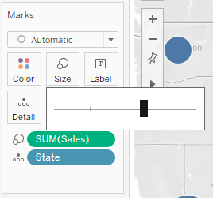
By adding a geographic field (State) to the Details mark, a map is created, with each state represented by a circle. By dragging the measure (Sales) to the Size mark, the circle markers on the map change size, depending on the share of total sales.
Looking at the size of each circle, it can be said that the Northeast US has the largest share of total sales.

Choropleth map
Question: Which US state on the west coast has the highest total profits?
- Open a new worksheet and name it Choropleth Map
- Drag the State field to the Details mark to create the map
- Drag the Profit field to the Color mark
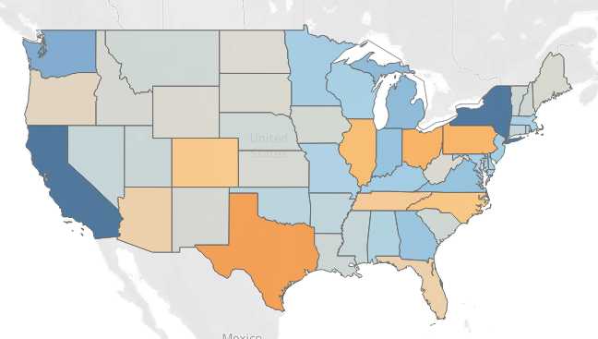
Unlike proportional charts, choropleth charts show sales values ​​as shades of color (in this case blue), with higher profit values ​​shown in dark blue.
The map shows that California has the highest profit. However, it can also be seen that Texas is making quite a loss. And what about sales?
Coropleth maps are great if you only want to see one numerical data on the map. However, what if you want to display two numeric fields on one chart – sales and profit?
- Drag the Sales field to the Size mark.
- Click on the Size mark to increase the size of the circle
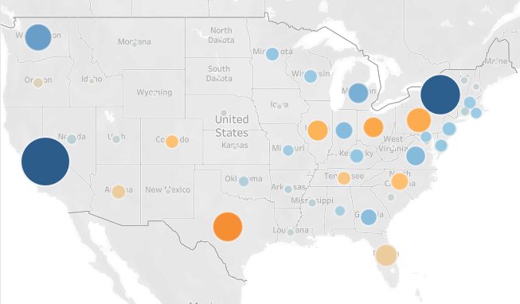

Now you have both profit (color) and sales (circle size) on one view.

Formatting

Labels
- Load the Global Superstore file
- Create a new worksheet and name it Labels
- Drag the Sales field to rows, and Order Date (display by month, continuous) to columns
- Drag the Region field to the Color mark
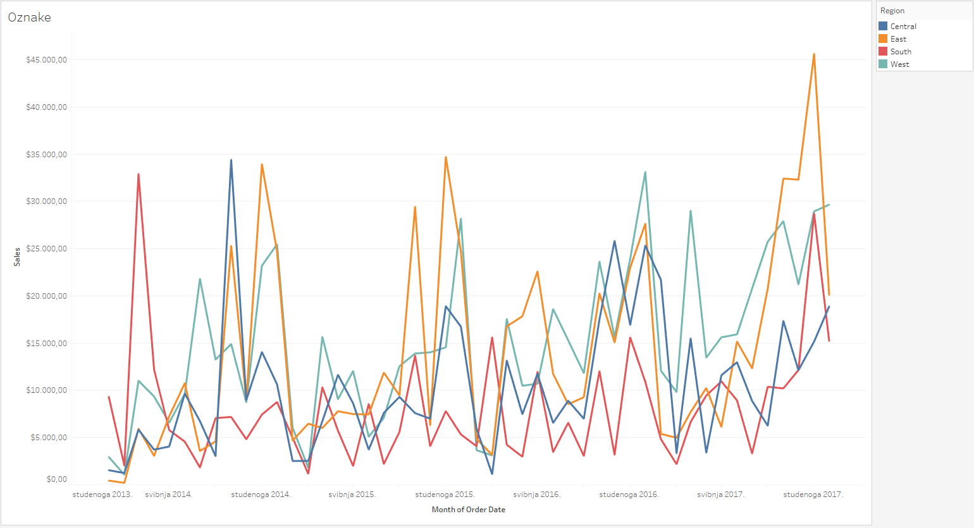
- Click on the Label mark and select the Show mark labels option.
Now the tops of the line chart have sales values ​​displayed. Labels are displayed only on those peaks where the text does not overlap and after which the visualization looks transparent.
- If you want to always (or never) see a specific label, right-click on the desired point on the graph (the top of the line), select the Mark label option and mark the desired option, eg Always show.

Annotations

Annotations represent text that explains some phenomenon or mark on the chart. There are several types of annotations.

Mark annotations
Mark annotations are linked to marks (points) on the chart.
- Open the Labels worksheet
- Drag the Region field to the filter and filter only the Central region
- Right-click the September 2011 mark and select Annotate > Mark
- A window for entering the annotation text opens. By clicking on the Insert button, you can also insert the fields used in the visualization into the text. Enter the text shown in the image:
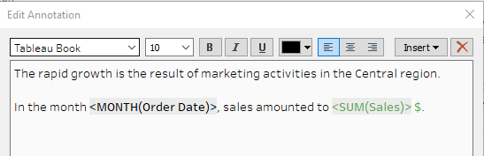
Now the annotation associated with the label is also displayed on the chart.
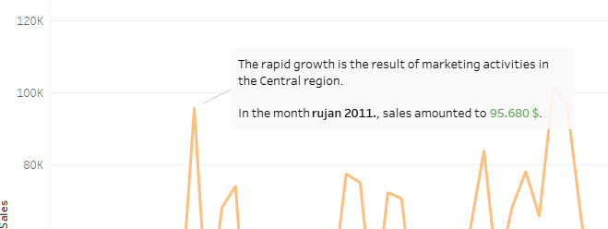

Point annotations
Point annotations remain in a relative position, independent of the mark on the chart, and can be placed outside the chart.
- Right-click anywhere on the chart and select Annotate > Point
- A text box for formatting the annotation opens. You can only use fields that are in columns and rows to format this annotation.
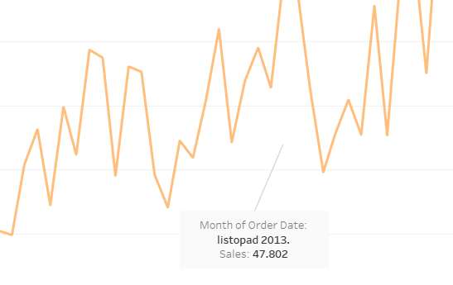

Tooltips
- Create a new worksheet and name it Tooltip
- Hold down the CTRL key and select the Sales and Profit fields
- Click the Show me button and select Scatterplot
- Drag the Order Priority field to the Color mark, and the Orders (Count) and Market to the Detail mark
- Change the chart from Automatic to Circle and increase the size of the circles
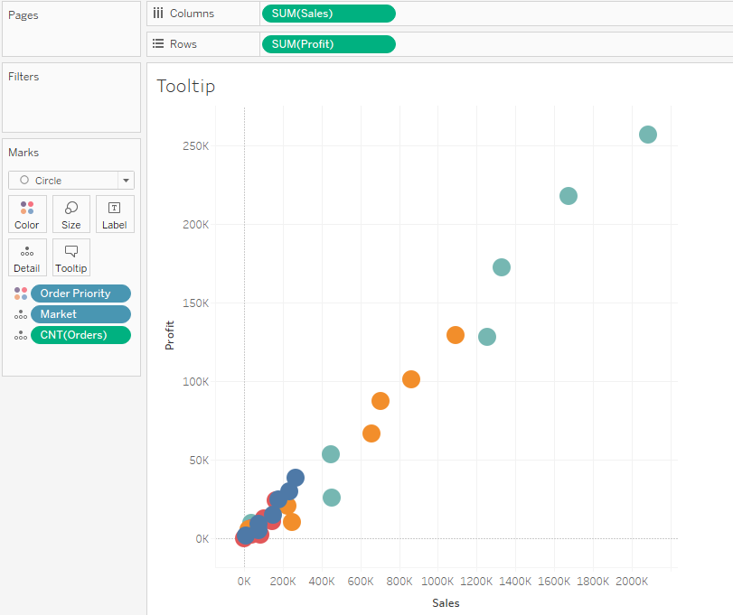
If you move the mouse over one of the circles, a tooltip with information opens. The tooltip contains all the fields that are also on the visualization (in rows and columns, Marks section).
- On the left side, in the Marks section, click on the Tooltip mark
- A tooltip editing window opens. Change the tooltip as follows:
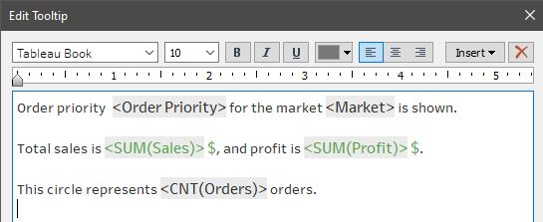
By clicking on a specific circle on the graph, a tooltip will appear.
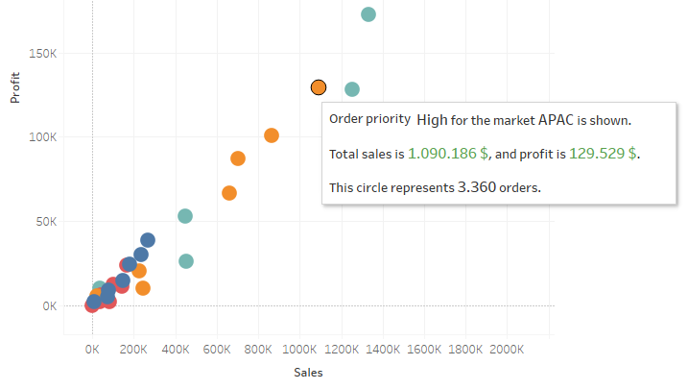

Dynamic titles
By default, the title of each visualization is taken from the name of the worksheet. However, the titles of visualizations can be fixed, that is, arbitrary titles can be entered, but they can also be dynamic, which means that they change as a certain item changes.
- Open the Labels worksheet
- Right-click on the Region field in Filter and select Show Filter
- Double-click on the title of the visualization (Labels)
- A window for editing the title opens. Modify it as follows:
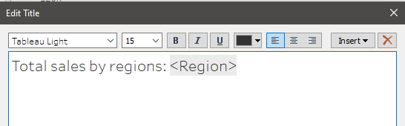

Now, the title changes as the data is filtered by region.
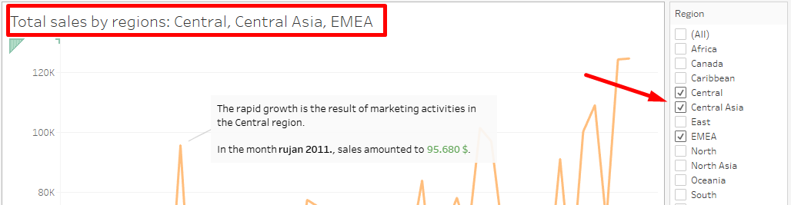

Placing names next to the lines themselves on the graph
- Open a new worksheet and name it Profit by Category
- Drag the Order Date field to columns and Profit to rows
- The Order Date field should be continuous and show the year
- Drag the Category field to the Color mark
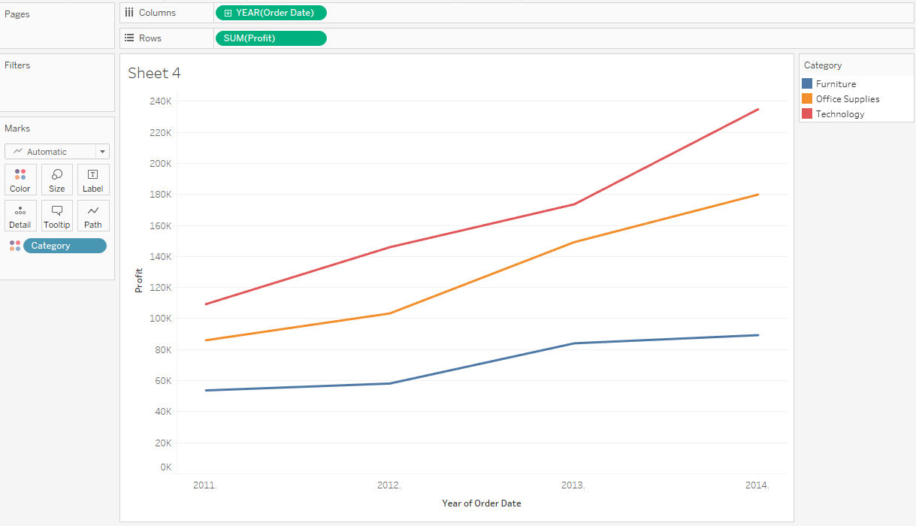
- Drag the Category field to the Label mark once more
- Click on the Label mark and edit the font in the window that opens:
  - Set the size to 11 and make it bold
  - Select the Match Mark Color option
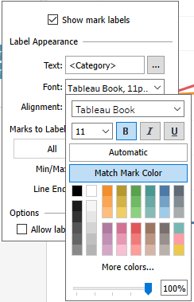

Parameters
Parameters are used if we want the visualization to change, depending on the fields that the user chooses himself.
- Create a new worksheet and name it Parameter
- Click on the arrow in the upper right corner of the Data panel and select Create Parameter
- Name the parameter Metrics, the data type should be String, and under Allowable values ​​select List. Enter 3 items in the list:
  - Sales
  - Profit
  - Shipping cost
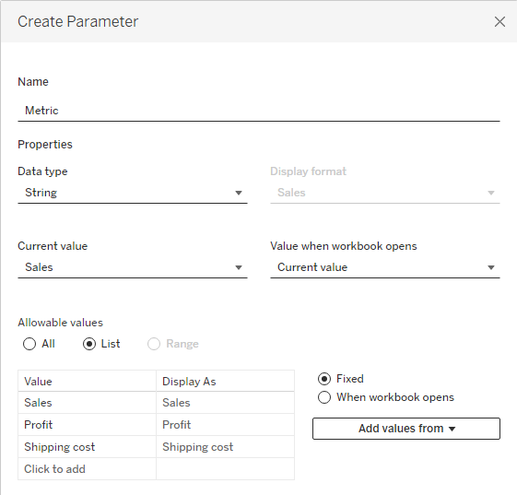
- Now in the panel on the left, at the bottom, there is the newly created parameter Metrics. Right-click on it and select Show parameter.
Now it is necessary to create a calculated field that will display the measure (variable) that we select in the parameter on the visualization.
- Create a new calculated field and name it Selected metric. The function that will check what is selected in the parameter and, accordingly, display the necessary measure, reads:
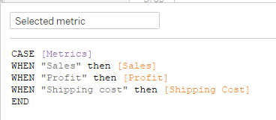
- Drag the Category field to columns, and the Selected metric to rows
Depending on what you choose in the parameter on the right, you will get a visualization view (sales, profit or shipping costs by category).
- Double-click on the graph name (Parameter) and change the name so that it is dynamic, that is, it changes depending on the selected parameter:
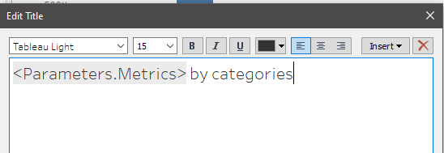

Dashboards and storytelling
A dashboard is a collection of worksheets and other information displayed on one screen. When creating a dashboard, it is necessary to pay attention to the following:
- It is necessary to know who your audience is, to whom will you present the information?
- The most important content on the dashboard should be located in the upper left corner
- Limit the number of visualizations on the dashboard (no more than 5)
- Use filters to make the dashboard more interactive
- Emphasize important information

- Open the Tableau file Tableau - dashboard
- Create a new dashboard and call it Sales KPI
- At the top, in the Dashboard menu, under the Device Layouts option, add Desktop
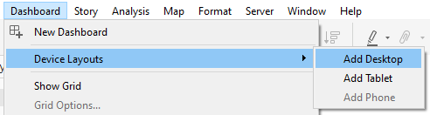
- In the panel on the left, select Default
- At the top of the menu, click on Format > Dashboard. In the panel on the left, change the Dashboard Shading to light gray
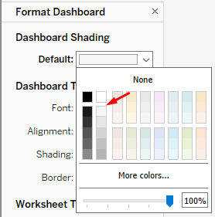
- Close the Format Dashboard panel by clicking the X
- Drag the Sales by Salesperson worksheet to the dashboard
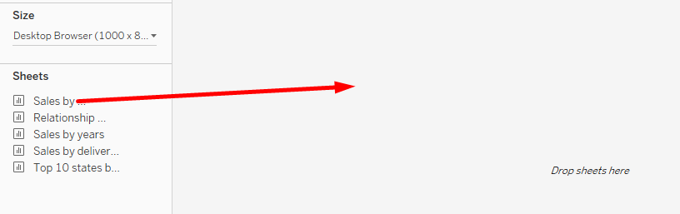
- Move the Sales by delivery type worksheet below that visualization
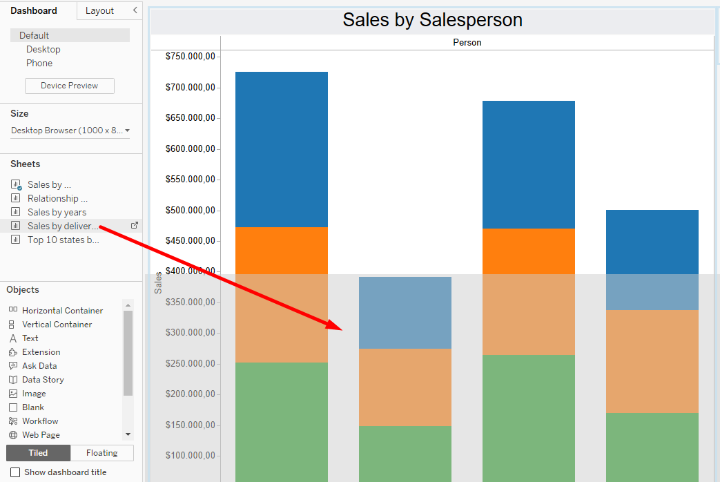
- Move the Sales by years worksheet to the right of that visualization
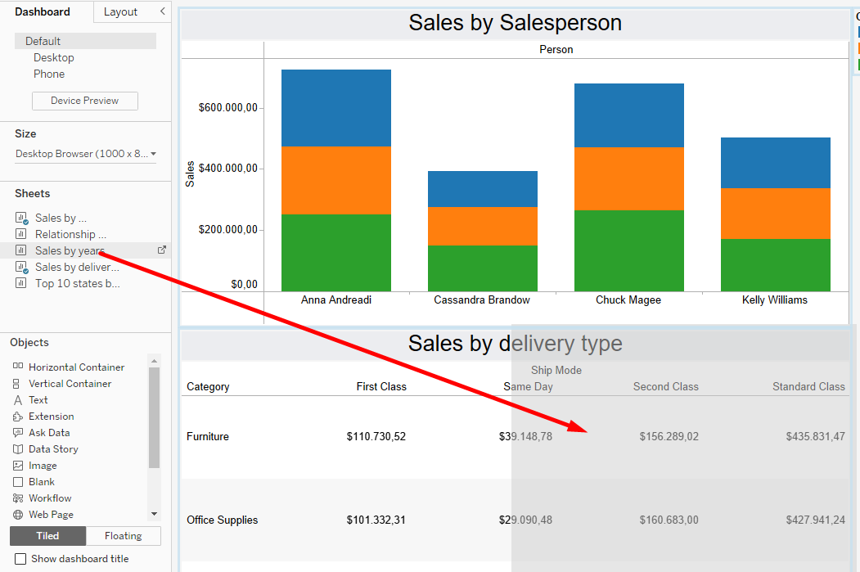
- Drag the Text object to the upper left corner
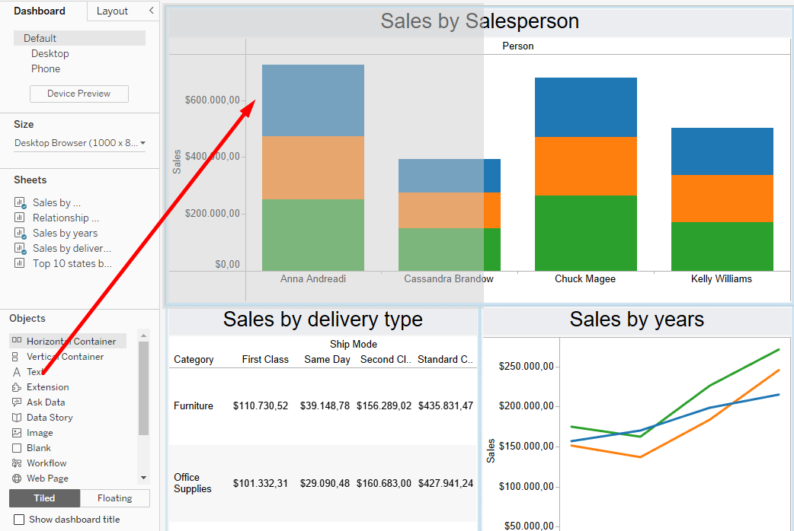
- In the window that opened, type the text Superstore sales and increase the font size to 22
- Adjust the size of the Text object so that it occupies approximately 1/3 of the width of the dashboard
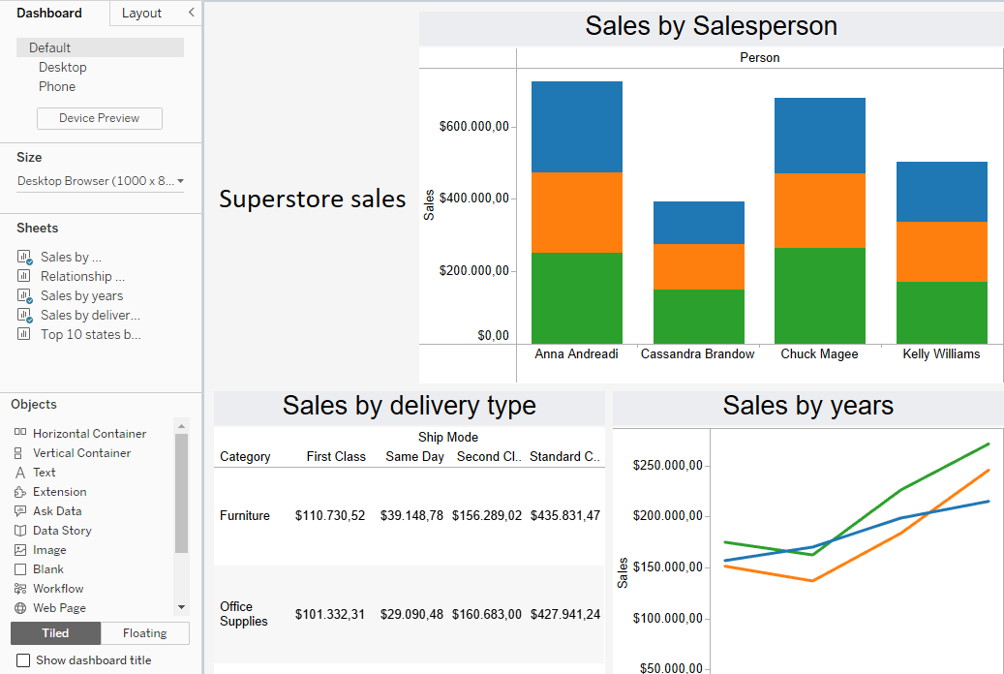
After dragging all the worksheets, a dashboard was created. After creating the first initial appearance of the dashboard, it is now necessary to further customize it. By deleting a visualization from the dashboard, the appearance of the dashboard will automatically change. However, replacing one visualization on the dashboard with another will not affect the appearance of the dashboard.
- Click on the chart Sales by delivery type
- In the panel on the left, hover over the Top 10 countries by sales worksheet
- Click on the curved arrow on the right side of the worksheet
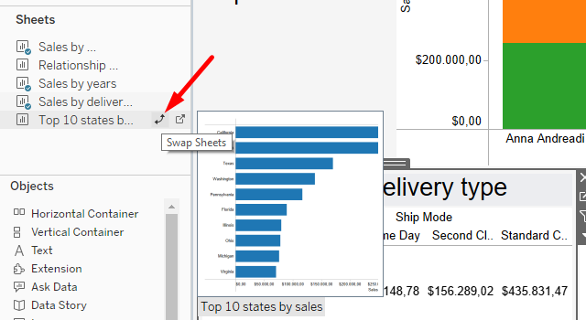

Dashboard interactivity
Depending on the context of the dashboard, it is possible to give the audience the ability to dig deeper into the data.
Question #1: What are the top 3 countries in terms of product sales in the 'Technology' category?
- Click on the visualization Sales by years
- Click on the arrow on the right. In the menu that opens, select Use as Filter
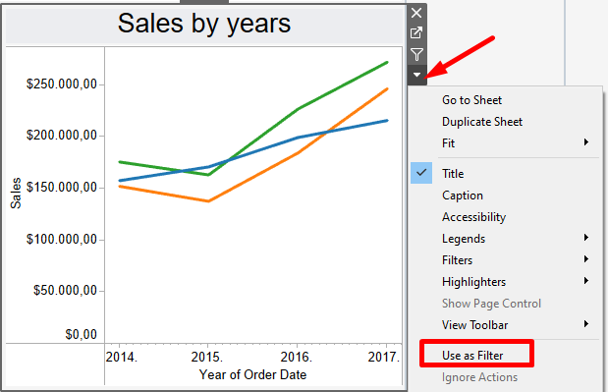
By selecting this option, the filter is also applied to other visualizations. When you click on a line on the line graph Sales by years, the other visualizations will also change according to the selection. You can do the same by clicking on the funnel (filter) icon.
After selecting the green line that indicates the Technology category, it can be seen that California, New York and Pennsylvania have the highest sales.
- Using the Blank object, edit the dashboard by adding blank space between the visualizations to make them clearer

Tableau story
Tableau story combines worksheets and dashboards with the goal of telling a story about visualizations.

Question #1: What is the sales situation in the last 5 years
- Create a new story by clicking on the last icon at the bottom of the screen and name it Superstore sales
- Drag the Sales by Salesperson sheet to the first story point
- Change the title of the story point so that it says "3 out of 4 referrals have sales of more than $500,000"
- Drag the Sales by years worksheet to the right of the name of the first story point and release
- Change the name of the second story point to "Sales in all categories have increased over the years"
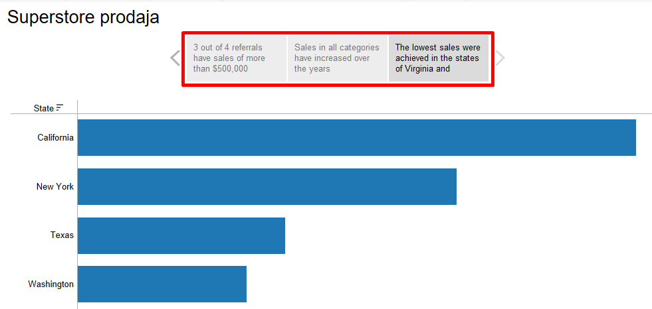
- Drag the worksheet Top 10 states by sales to the right of the name of the second story point and release
- Change the name of the third story point to "The lowest sales were achieved in the states of Virginia and Michigan"
Within each story point, it is possible to add annotations:
