BUSINESS ANALYTICS SKILLS FOR THE FUTURE-PROOF SUPPLY CHAINS | BUSINESS INTELLIGENCE  Tableau desktop  Exercises handout  Authors:  Dario Šebalj  Final version:  June 2025

Exercise 2

Most common types of charts

In this exercise, the most common types of graphs used in visualizations will be shown:
- Bar chart
- Line chart
- Scatterplot diagram
- Histogram
- Heatmap

Bar chart
Question #1: Which product categories and subcategories sell the most? Are all products profitable?
- Open Tableau, load the Global Superstore file (Orders worksheet)
- Open a new worksheet and name it Bar chart
- Analyze sales by categories and subcategories. Drag the Category field into columns, and the Sales field into rows. Additionally, add the Sub-category field to the columns, to the right of the Category field
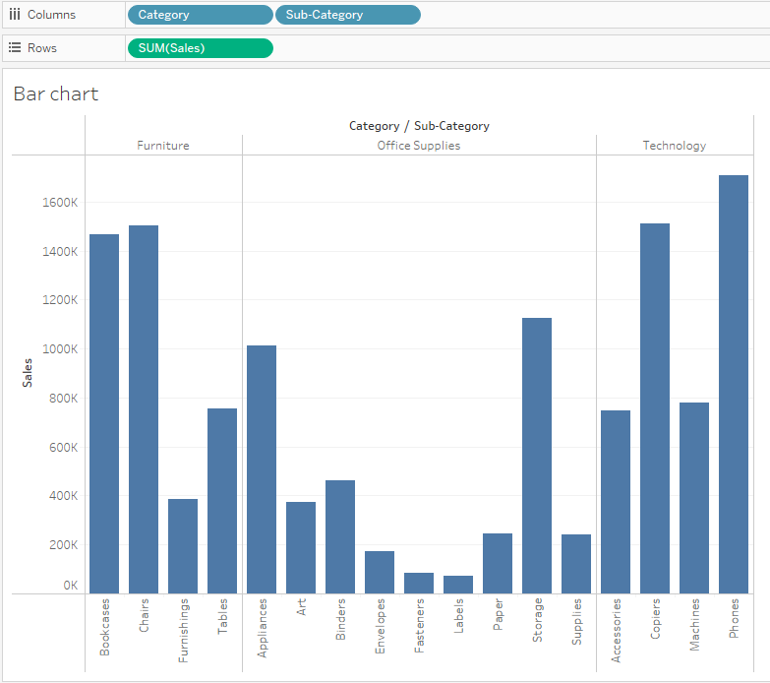
This chart is not easy to read since the subcategory labels are turned vertically and there are a relatively large number of columns. The solution is to rotate the chart and create a horizontal chart.
- Click the Swap icon in the toolbar to rotate the chart. After that, sort it by size by clicking the Sort icon

Which product category (subcategory) sells the most? What about the other categories?
- Add the Profit field to the Color mark so that you can analyze another continuous variable on the same chart.
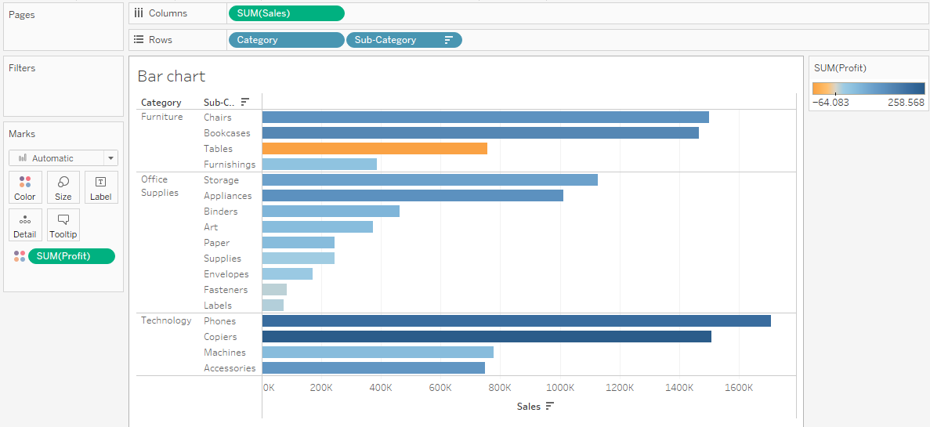
What happens to the profits? What is the relationship between sales and profit?
It can be seen that the tables are selling quite well, but they are not profitable.

Grouping
The Office Supplies category has several smaller subcategories that, viewed separately, are not that relevant compared to the other subcategories. Such data can be grouped.
- Select the Envelopes, Fasteners and Labels sub-categories (hold CTRL and select each individual subcategory on the chart) and click the paperclip icon to group them
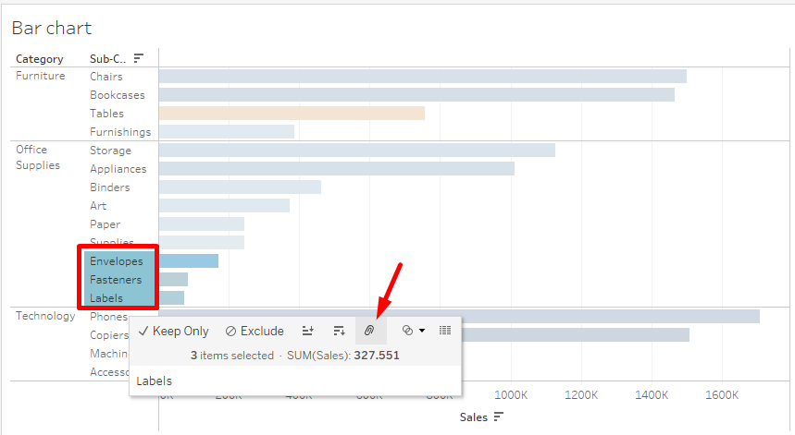
- In the visualization, the data were grouped under the name Envelopes, Fasteners, Labels. Rename the name by right-clicking on it and selecting Edit Alias ​​from the menu. Enter Small Office Supplies under the name.
In this way, the actual data (in Excel) is not changed, but the change was made only in the visualization. Only a new field was added in the dimensions – Sub-category (group).

Overview of all background data
- It is obvious that there is a certain problem with the tables. Right-click on Tables and select Keep Only to explore them further.
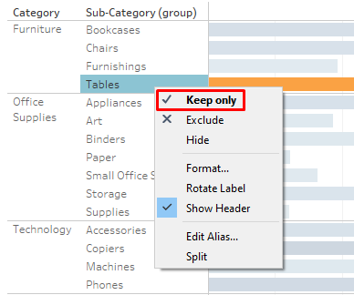
- Drag the Product Name field into the columns (next to the Sub-category field). Sort data by size (from largest to smallest)
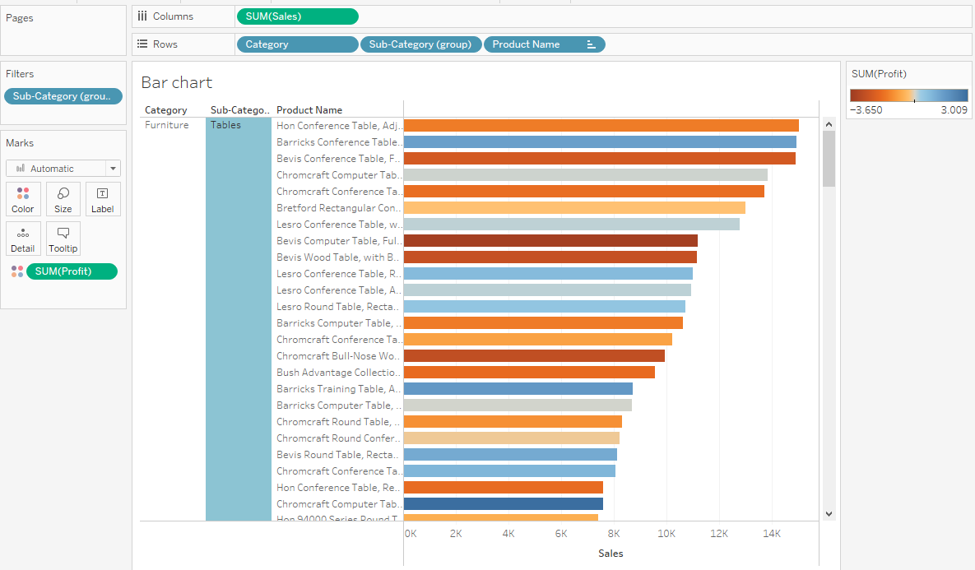
It is evident from the above that some tables sell well and are profitable, while some are extremely unprofitable. Now it is necessary to look at all the information (actual data) about the product.
- Right-click on the first column (first product) and select View Data. In the window that opened, click on Full Data on the left. Add some other fields that you may be interested in, eg the Discount field.
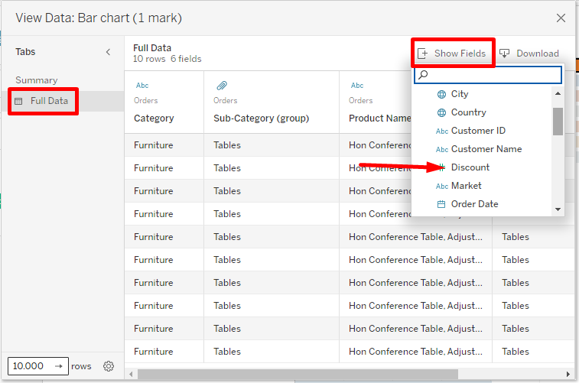
What do you notice in the displayed data?

Line chart
Question #2: How have sales progressed over the years?
- Open a new worksheet and name it Line chart
- Move the Order Date field to columns, and the Sales field to rows
- Break down the date into quarters, and then into months. Remove the quarters from the visualization.
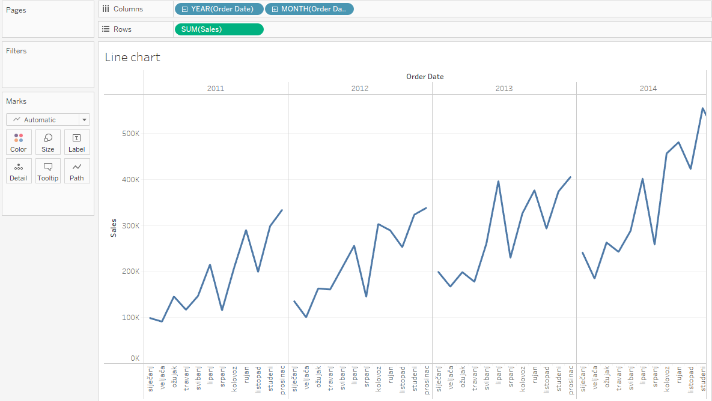

Dual axis vs. Combined axis
Dual-edge charts are good for displaying two different pieces of data on the same chart, so that each piece of data has a different value scale. At the same time, each piece of data can be displayed with a different type of graph.
- Drag the Profit field into the rows (next to the Sales field). You got separate views for sales and profit trends.
- Now remove the Profit field from the rows and drag it to the right edge of the chart
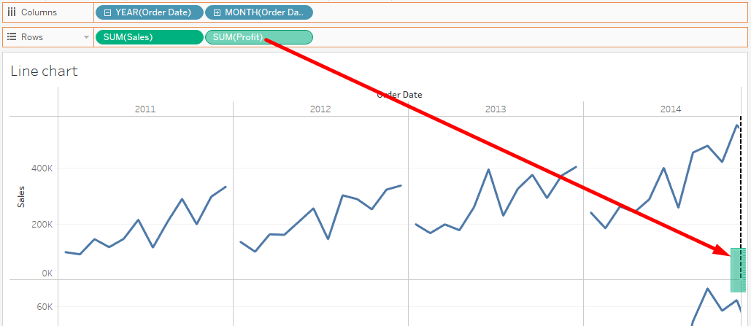
You got a display of the values ​​of both fields (sales and profit) on the same chart. Each field has its own axis, or scale. Sales values ​​are shown on the left axis, and profits on the right axis.
On the left side, in the Marks section, you can now choose the type, size and color of the chart and other parameters for each field (both Sales and Profit). In this way, the so-called combined chart is created.
- Open the SUM(Sales) mark and select Bar as the chart type
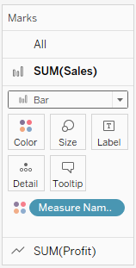
You got the display of 2 different charts on the same visualization (combined chart).
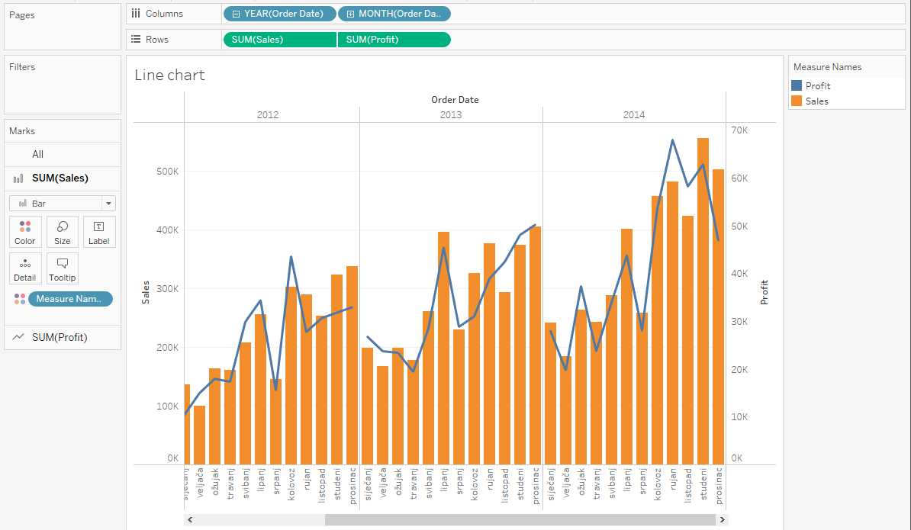
What's the problem with this display?
This visualization can be misleading because the left and right axes are not synchronized.
- Right-click on the right axis and select Synchronize Axis
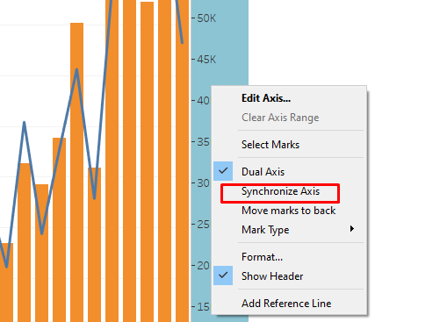
On the other hand, combined axes display two or more measures on one axis (they use the same scale).
- Right-click on the Profit field in the rows and turn off the Dual Axis option. Now remove the Profit field from the rows and drag it to the left edge of the chart
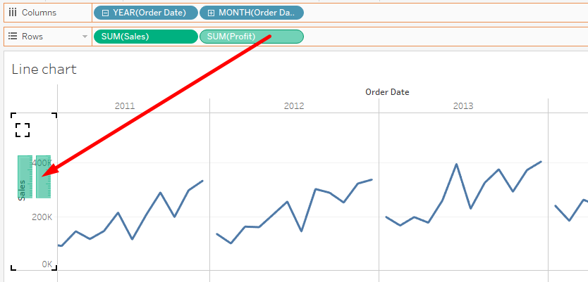

You got a display of the values ​​of both fields (sales and profit) on the same chart, but on a common axis. All fields are displayed with the same type of chart. In this way, it is possible to add more measures.

Year over year growth
- There are some frequent calculations on time series data, such as annual growth (so-called YOY growth – year over year growth). Right-click the SUM(Sales) field in the rows. Select Quick Table Calculation > Year over Year Growth
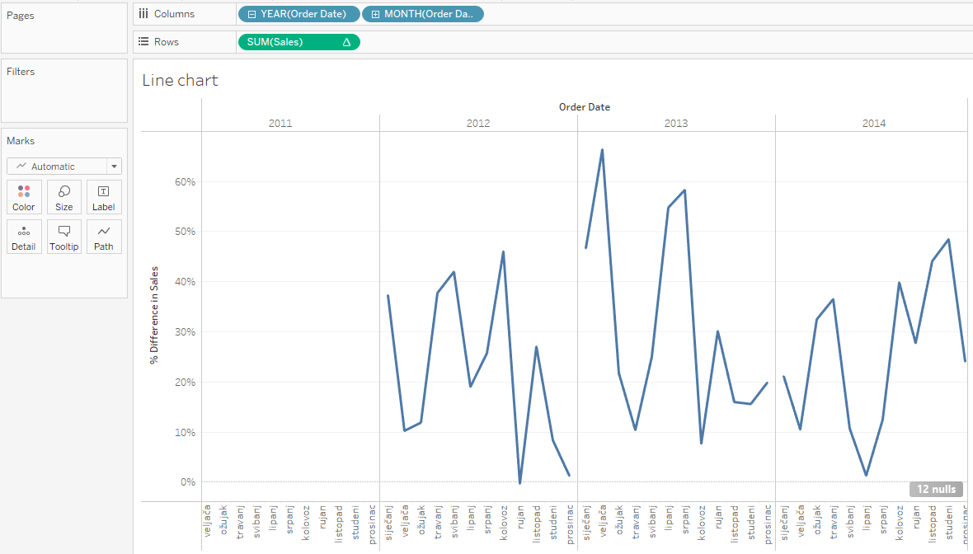

In which months did sales decline compared to last year?

If you move the mouse to one of the points on the graph, you can see the increase/decrease in sales compared to the same period last year. For example sales in August 2012 were over 46% higher than a year earlier.

Adding reference lines
Various reference lines can be added to the graphs (e.g. average values ​​or some fixed values ​​that will be used for comparison.
- Right-click the SUM(Sales) field in the rows and select Clear Table Calculation. On the left, in the Analytics tab, select Average Line and drag to the visualization. Tableau will offer 3 options:
  - Tables – if you want to display the average of all observed years (total sales)
  - Pane – if you want to display the average of each individual year
  - Cell – if you want the average of each month to be displayed
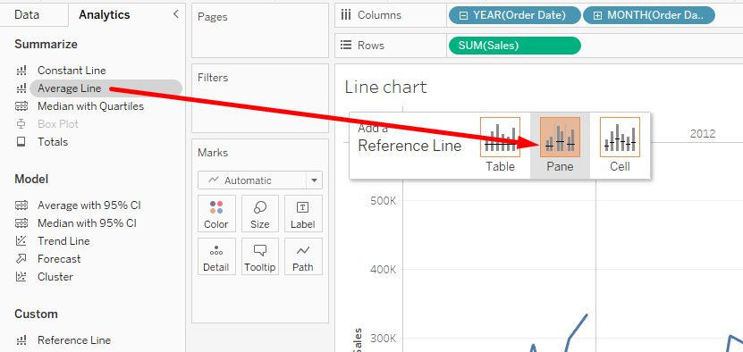

Forecasting
Tableau has built-in capabilities to predict (forecast) future values.
- On the left side, in the Analytics tab, select Forecast and drag it to the visualization (on the Forecast field).
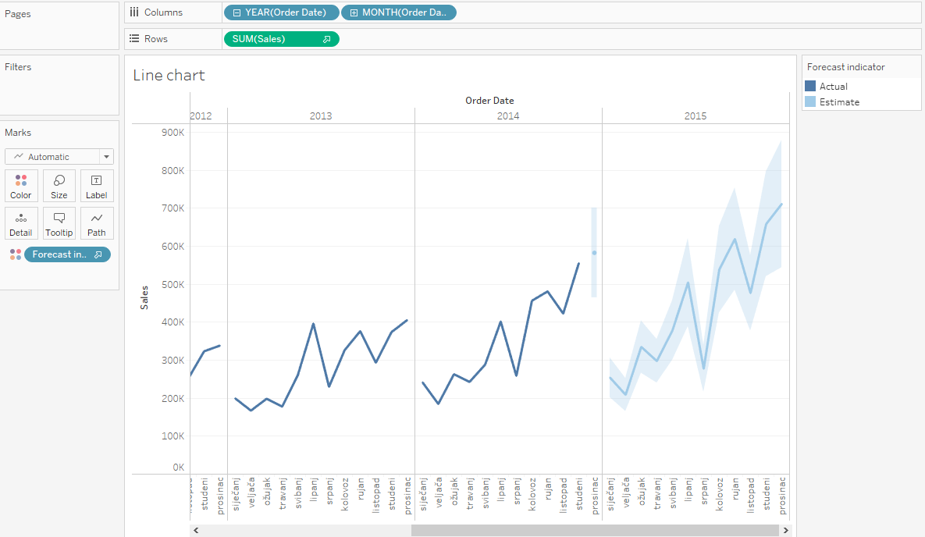
The sales forecast for 2015 is shown (dark blue line), with possible certain deviations (light blue area).

Scatterplot diagram
Question #3: Is there a correlation between profit and discount? Will a higher profit be made if the discount is lower?
- Open a new worksheet and name it Scatterplot
- Click on the Profit field, hold CTRL and click on the Discount field
- In the upper right corner, click on Show me and select Scatter plot from the chart list
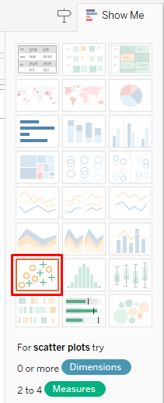
The chart now shows only one point comparing total sales to total profit. In order to get a display of all orders and thus see if there is a correlation between profit and discount, it is necessary to add a dimension to the visualization.
- Drag the Row ID field to the Detail mark.
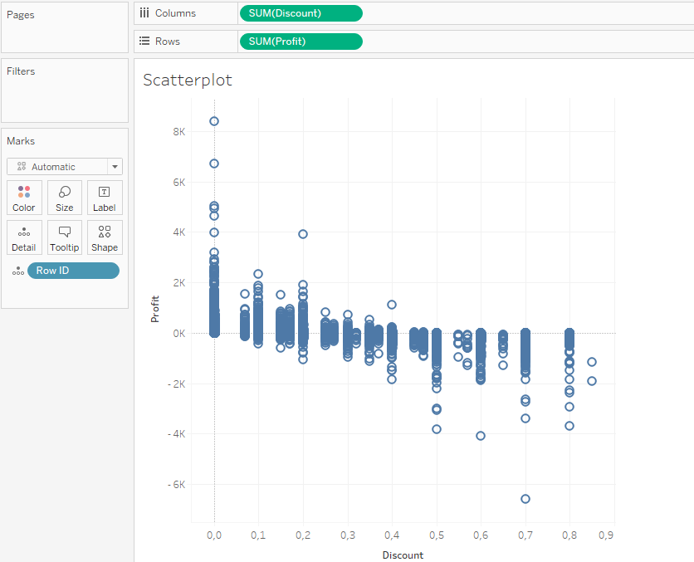
- On the right side, in the Analytics tab, select Trendline and drag it to the visualization (on the Linear field)
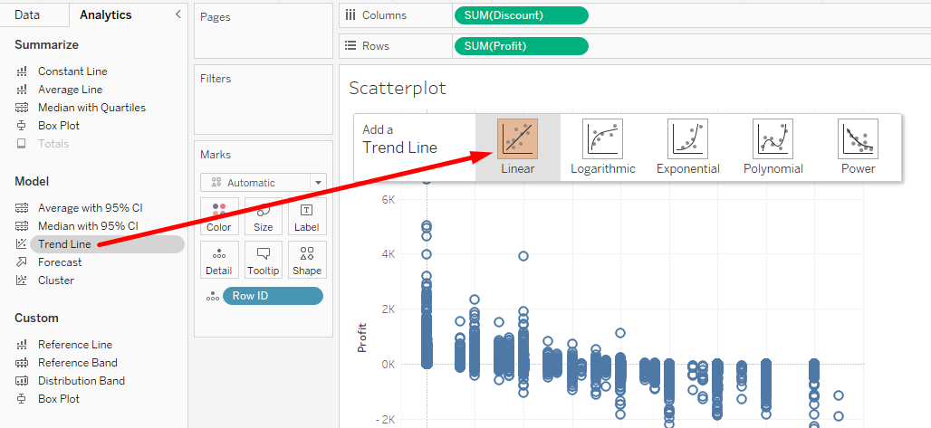
A trend line is now displayed on the visualization. By moving the mouse over it, it is possible to see certain statistical parameters.
Describe the diagram - is there a correlation, what is it like, what does the linear correlation coefficient (R-Squared) show us, and what does the p value show?
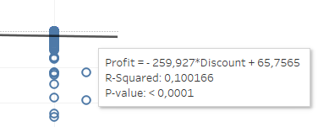

Histogram
Question #4: How many orders are there with specific discounts, grouped into groups (0-10%, 10-20%...)?
- Open a new worksheet and name it Histogram
- Click on the Discount field, in the upper right corner click on Show me and select Histogram from the chart list.
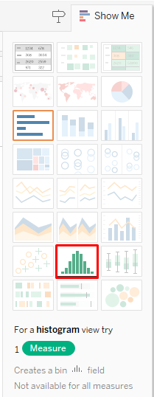
- On the left side, in dimensions, a new field Discount(bin) is created. Right-click on that field and select Edit. Change the class size to 0.1.
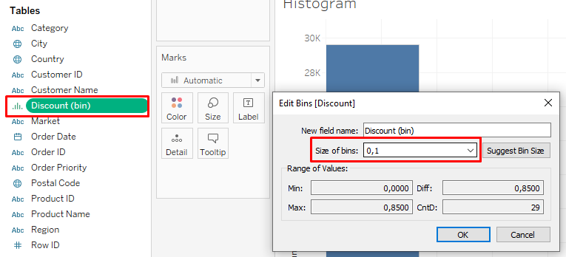
What can you conclude from the graph? How many orders have a discount between 80 and 90%?
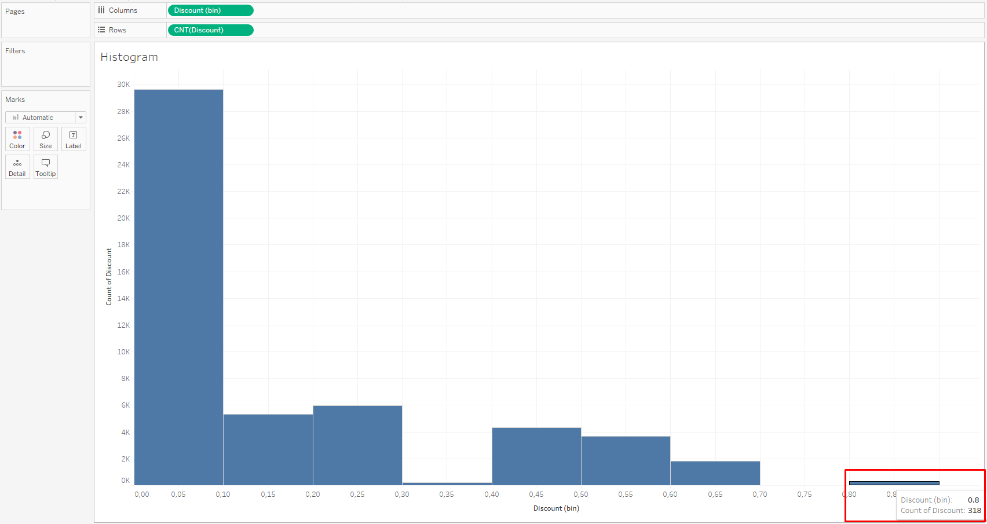

Heatmap
Question #5: How did furniture sales move by month and category? Show all furniture subcategories. In which month is the most furniture sold?
- Open a new worksheet and name it Heatmap
- Move the Order date field into columns, and the Category and then Sub-category fields into rows. You have received a table with columns and rows. Move the Sales field to the body of the table (to Abc).
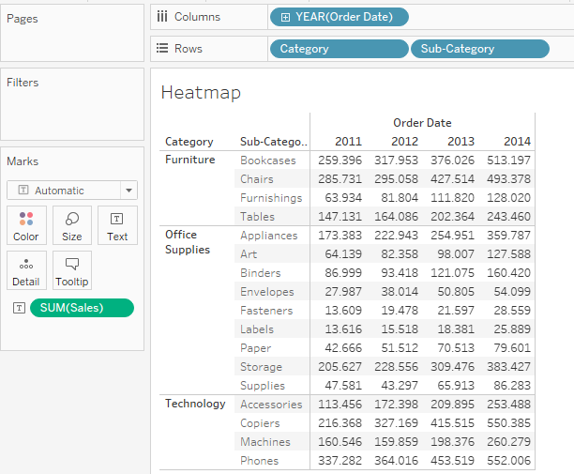
- Drill the date down to the month level. Remove year and quarters.
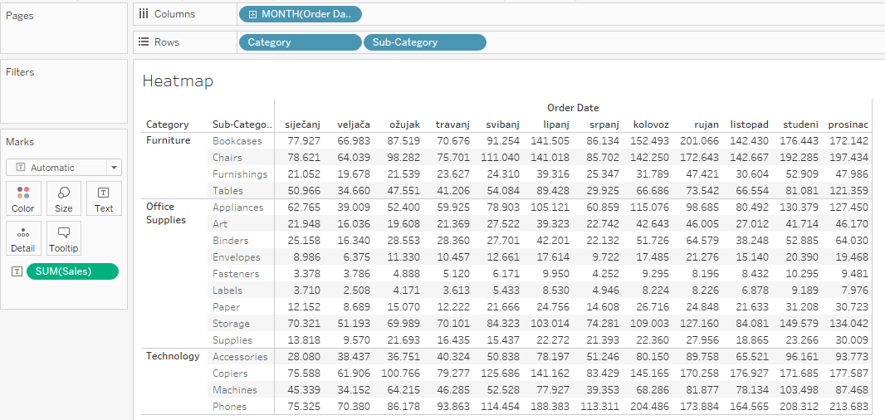
- Filter only the Furniture category by dragging the Category field to the Filters section. In the window that opens, mark only Furniture.
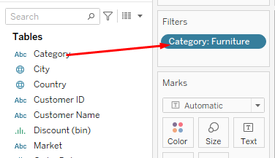
- Right-click Furniture on the chart and uncheck Show Header
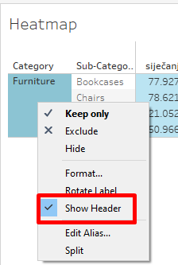
- Drag the Sales field in the Marks section to the Color mark
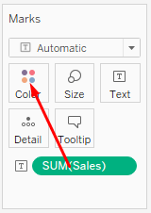
You got a heat map on which it is easy to see that December is the month with the highest sales.
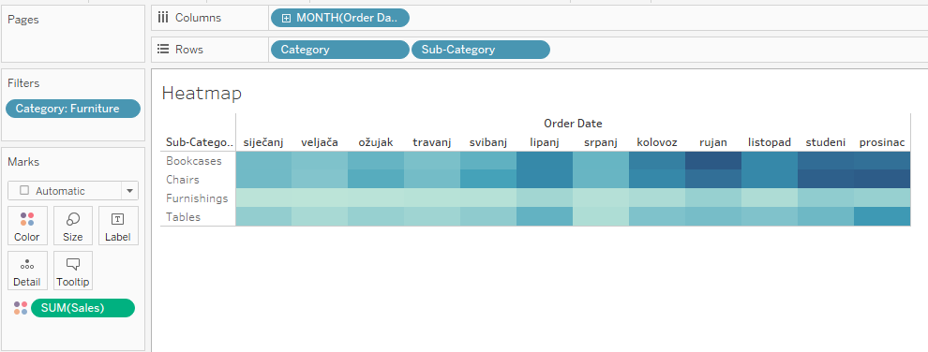
By double-clicking on the color scale on the right, it is possible to change the color palette (eg orange-blue).

Calculations
Tableau allows you to create your own fields (dimensions or measures), based on calculations. They are used if the data does not contain all attributes (all fields) required for analysis. For example, if there is no field in the data that indicates the margin, it is possible to manually create that field and enter a formula that will calculate the margin.

Totals
- Open the Tableau file Tableau - Calculations
- Open a new worksheet and name it Totals
- Drag the Person field (from the People table) to columns, and the Order date to rows
- Drag the Sales field to the Text mark
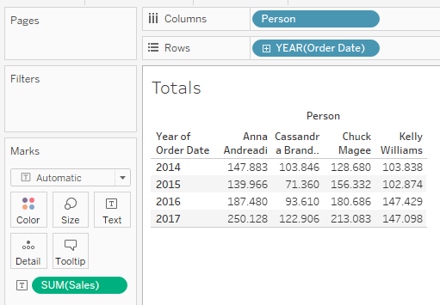
- On the left side, in the Analytics tab, select Totals and drag to the visualization, to the Column Grand Totals field to get the sum of the values ​​in the columns.
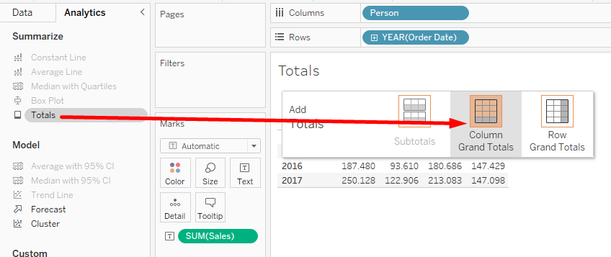

It is evident from the above that Anna Andreadi had the highest sales.
The same can be done via the top menu Analysis > Totals > Show Column Grand Totals for column totals and Show Row Grand Totals for row totals.
It is evident from the above that the highest sales were achieved in 2017.

Simple calculations
- Open a new worksheet and name it Simple Calculations
- Move the Sub-Category and Product Name fields to rows
- Move the fields Sales, Profit and Quantity into columns
- Open Show Me and select Text Tables
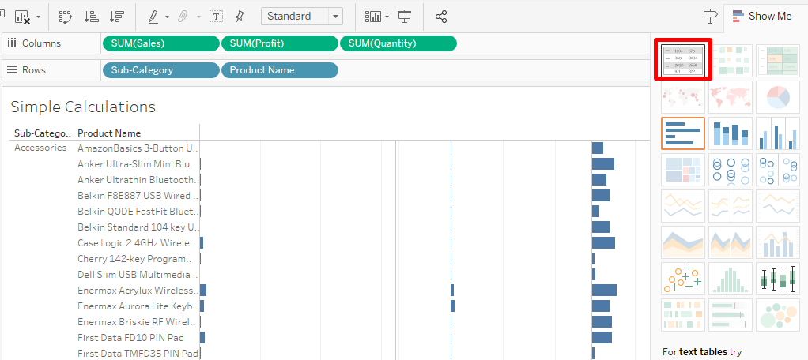
- Arrange the columns so that they are displayed in the following order: Sales, Profit, Quantity.
Using the calculated fields, sales and profit can be calculated for a unit of product, that is, the costs per unit of product sold can be determined.
- Open the Analysis menu at the top and select Create Calculated Field
- Name the field Sales per unit and enter the following formula:
SUM([Sales])/SUM([Quantity]). Click OK.
On the left, in the list of fields, a new field Sales per unit appeared. To the left of the field name is the = sign, which indicates that it is a calculated field (that it was manually created).

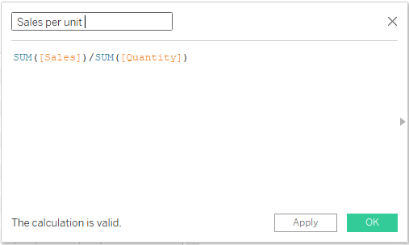
- In the same way, create a new calculated field Profit per unit using the formula:
SUM([Profit])/SUM([Quantity]). Click OK.
- Drag the newly created fields Sales per unit and Profit per unit to the Measure Values ​​section
- Sort the fields as follows: Sales, AGG(Sales per unit), Profit, AGG(Profit per unit), Quantity
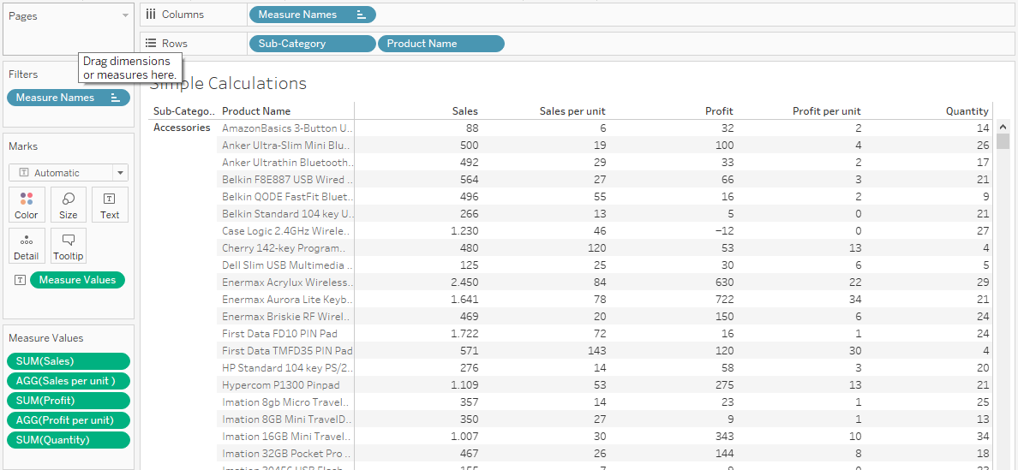

Create a new calculated field Cost per unit using the formula:
[Sales per unit]-[Profit per unit]

Drag the newly created field to the Measure Values ​​section

String functions
String functions enable the manipulation of text data.
The Customer Name field consists of the customer's first and last name. We want to make two special fields - one for the first name and the other for the last name.

Open a new worksheet and name it String Function

Move the fields Customer Name to rows, and Sales to columns

Create a new calculated field Surname using the formula:

SPLIT([Customer Name]),' ',2)

The SPLIT function consists of 3 parameters - the text field that we want to split, the delimiter, i.e. the character by which we split the text (it can be a dash, slash, space...) and the token, i.e. a number that indicates which part of the split text will be in that field. In this example, we separate the field Customer Name, the delimiter is the space between the first name and the last name, and since the first name goes first and then the last name in the field, the token is 2.

In the same way, create a new calculated field Name using the formula:

SPLIT([Customer Name]),' ',1)

Replace the Customer Name field in the rows with the Last Name field by dragging the Last Name field over the Customer Name field in the rows

If-else function
- Open a new worksheet and name it Profit Analysis
- Drag the Profit field to columns, and Segment and Sub-category to rows
- Drag the Category field to the Filter section and filter only the Furniture category.
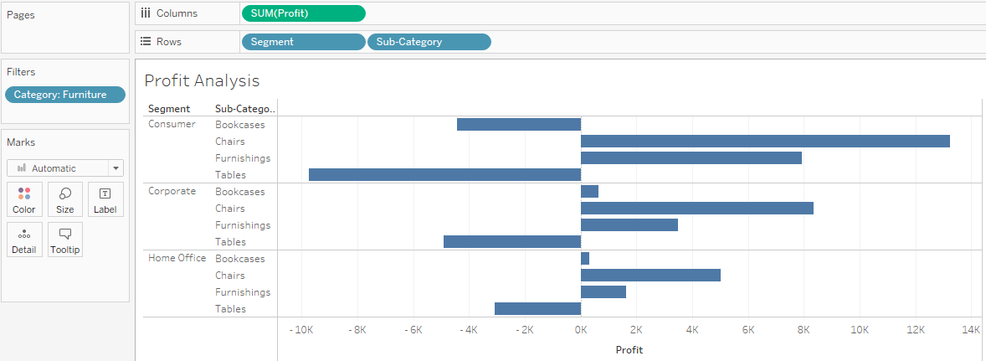
If we want to highlight those subcategories that have a loss (negative profit), then it is necessary to specify one color for positive profit and another color for negative profit. This means that a new calculated field needs to be created.
- At the top of the Analysis menu, select Create Calculated Field
- Name the field Profit - color and enter the following formula
IF SUM([Profit])>0 then 'positive' ELSE 'negative' END
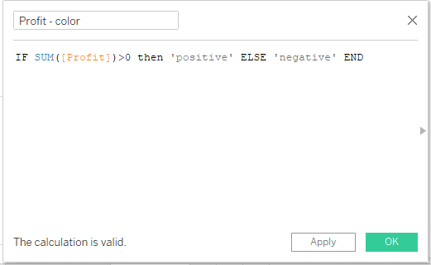
- Drag the newly created field Profit - color to the Color mark
- Change the color of the columns as desired
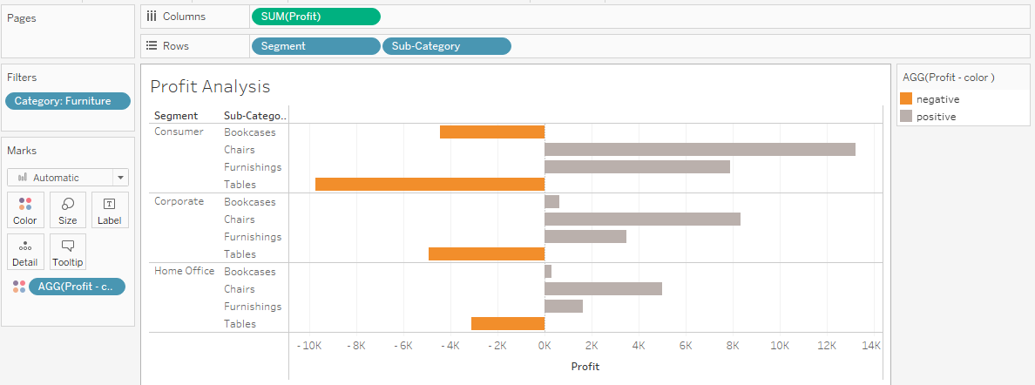

Date function
Question: What is the average delivery time by country?
Tableau contains a function that can calculate the time between two dates (eg between the delivery date and the order date).
- Open a new worksheet and name it Delivery Time
- At the top of the Analysis menu, select Create Calculated Field
- Name the field Delivery Time and enter the following formula
DATEDIFF('day',[Order Date],[Ship Date])
  - The 1st parameter is the "date part" which indicates at which date level the difference is calculated (day, month, year...)
  - The 2nd parameter is "start date" which represents the starting date
  - The 3rd parameter is "end date", which represents the final date
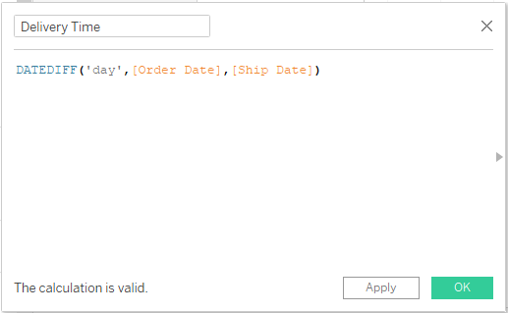
- Double-click on the Country field
- Drag the State field to the Detail tab
- Drag the Delivery time field to the Color mark and change its display type to Average:
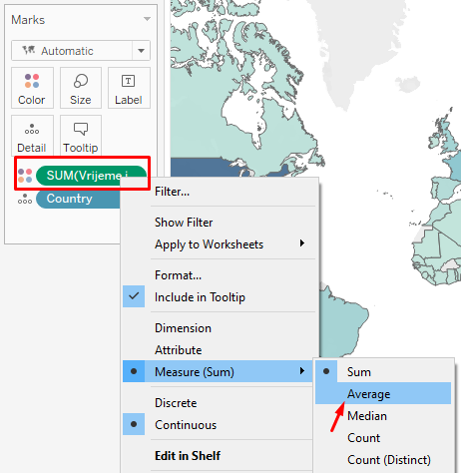
- Change the display color as desired
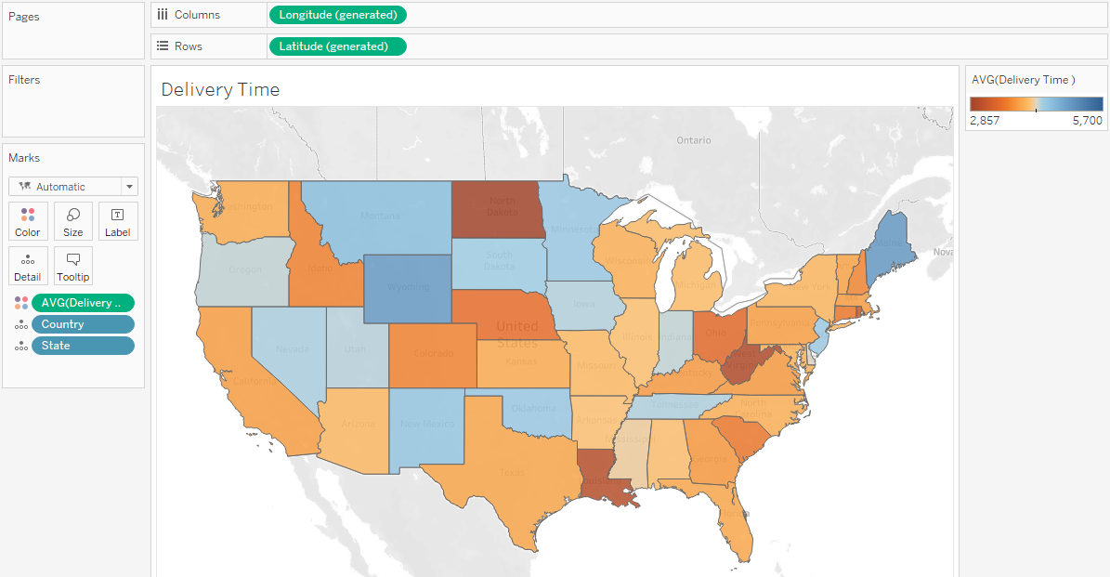

Table calculations
Question: We want to find out what percentage of the total sales for each individual seller falls into certain categories
- Open a new worksheet and name it Table Calculations
- Drag the Person and Category fields to rows
- Drag the Sales field to the Text mark
- Right-click the Sales field and select Add Table Calculations
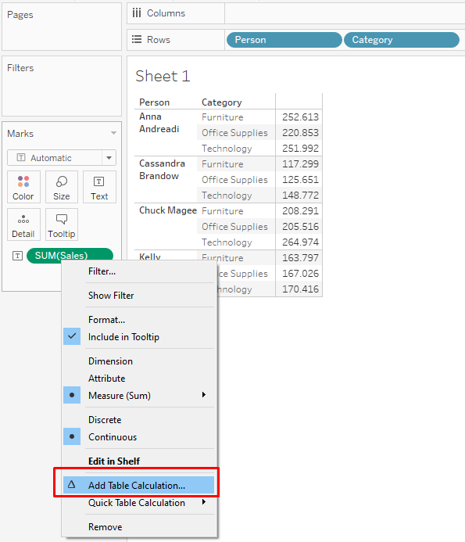
- In the window that opened, select the type of calculation on Percent of Total
- In the Compute Using section, select Pane (down)
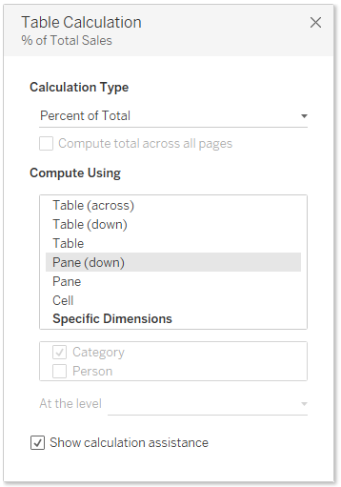
- Close the window by clicking the X in the upper right corner

Sets and hierarchies
Sets in Tableau are used to group or define a subset of data based on certain criteria (eg top 10 customers by sales).

Sets
Question #1: We want to see total sales by subcategory, but only highlight the top 10 subcategories in the chart.
- Open a new worksheet and name it Sets - Top 10 Subcategories
- Drag the Sub-Category field to columns and Sales to rows
- Right-click on the field Sub-Category in the list of fields on the left and select Create > Set
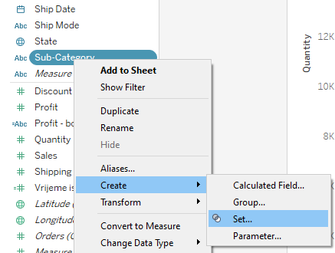
- Name the set Top 10 subcategories by sales
- Open the Top tab and check the By field option
- Set the Top field to 10, and by to Sales and Sum. Click OK.
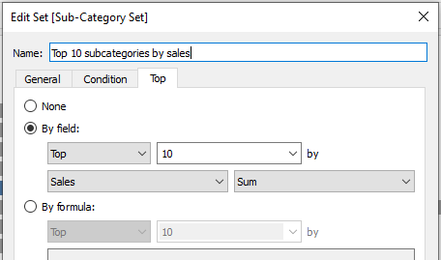
On the left side, in the list of data, a dimension has been added that has the word "Set" - Sub-Category Set. The icon of two overlapping circles, to the left of the field name, indicates that it is a set.
- Drag the newly created set to the Colors mark.
After adding the set to the Colors tab, the bar graph was displayed in two colors. A legend with the words In and Out has been added to the right. The In mark represents all values ​​that meet the criteria set in the By fields parameter. In this case, the chart shows the top 10 best-selling products.
The set that was created is dynamic and changes with the change (update) of the dataset.
- Remove the set from the Colors mark
- Hold the CTRL key and select several columns on the chart
- Move the mouse over a marked column to open the tooltip
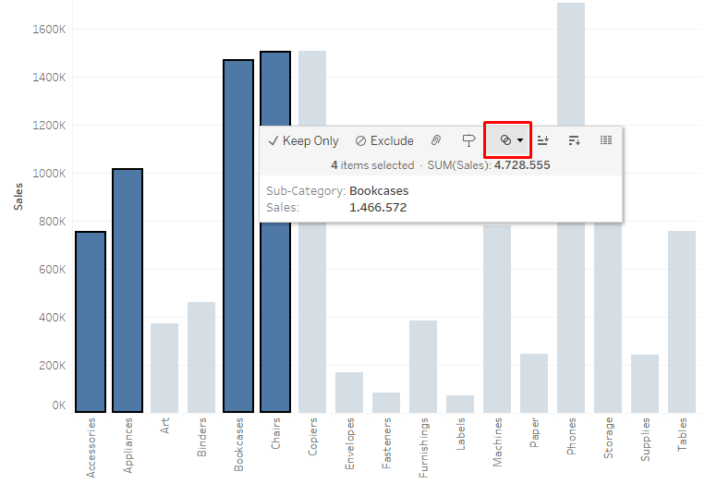
- Click on the two circle icon and select Create Set
- In the window that opened, click OK
- Drag the newly created set to the Color mark
The set that is now created is a fixed set that does not change (does not update) when changing the dataset, but will always take into account these specified values.

Question #2: We want to see total sales by subcategory, but have the graph highlight only the subcategories that are making a loss
- Open a new worksheet and name it Sets - Unprofitable Subcategories
- Drag the Sub-Category field to rows and Sales to columns
- Right-click on the field Sub-Category in the field list on the left and select Create > Set
- Name the set Negative profit by subcategory
- Open the Condition tab, check the By field option and set Profit < 0
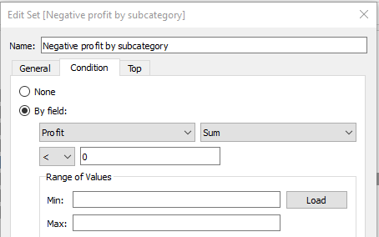
- Drag the newly created set to the Colors mark.

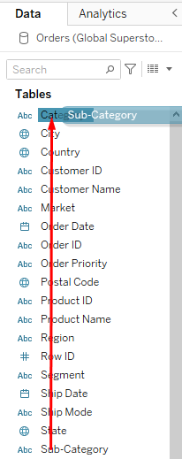
Hierarchies
Hierarchies serve to further explore the visualization (drill-down).
- Open a new worksheet and name it Hierarchies
- Drag the Sub-Category field to the Category field
- Rename the hierarchy to Categories
- Move the Categories hierarchy to columns, and the Sales field to rows
- Click on the '+' sign to display the subcategories as well

