Business Analytics Skills for the Future-proof Supply Chains | CASE STUDY  Survey Analytics  Authors:  Dejan Mirčetić  Marinko Maslarić  Final version:  June 2025

Content
BAS4SC – Business Analytics Skills for the Future-proof Supply Chains 2
TASK 4

BAS4SC – Business Analytics Skills for the Future-proof Supply Chains
In this case study, we analyze survey data collected from students, teachers, and companies across several countries, including Serbia, Croatia, Slovenia, and Poland. The primary goal is to summarize the survey responses, join skills revealed in the surveys, conduct ranking and sorting, and classify specific subjects into categories based on evaluation scores. We use R for data processing, manipulation, and summarization.

Problem Overview

The BAS4SC survey collects responses related to various aspects of education, skills, and professional development. The survey data is spread across multiple countries and different respondent categories (students, teachers, and companies). The challenge lies in:

- Summarizing the data to make sense of the survey responses.
- Joining skills revealed across different respondents and countries.
- Ranking and sorting the subjects based on evaluation scores.
- Classifying subjects into different categories based on performance evaluations.

For this purpose foloow the methofdology in Fig 1. which demonstrates the methodology for classifying the BAS skills to the three courses:

- C1: Advanced using of spreadsheet to analyse logistics data
- C2: Business Intelligence
- C3: Statistical method to analysing a logistics data.

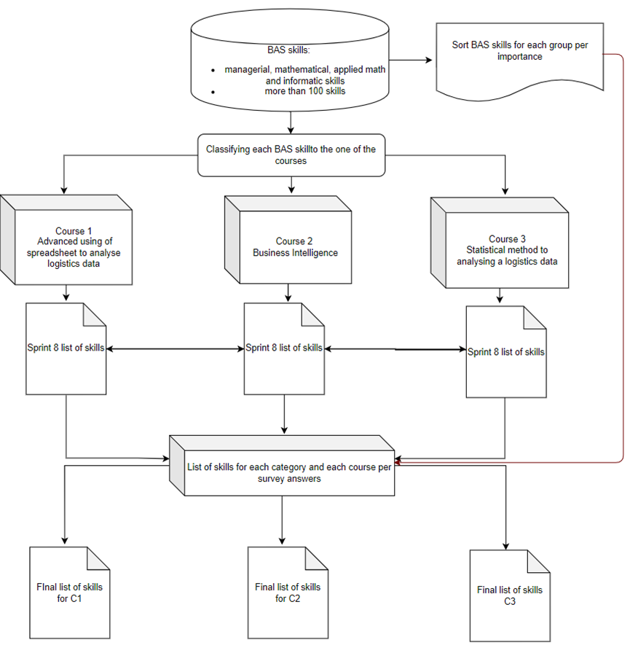
Fig 1. Methodology for classifying the BAS skills.

TASK
Approach and Procedure
The procedure used to analyze and process the data follows several key steps. First, we load and preprocess the survey data for each country (Serbia, Croatia, Slovenia, and Poland) and each respondent category (students, teachers, and companies). The data is read using the readxl package to load Excel files, and the dplyr package is employed for data manipulation.
Next, we summarize the responses using the sumarizator() function, which calculates the frequency of each response level. This function processes specific columns of the dataset, transposes the data, and returns a matrix with the frequency counts for each response level. For example, in the case of student responses, we process data from each country and generate frequency tables that show the distribution of response levels (e.g., "Not important", "Important") across various questions. These matrices are then reordered to improve readability and ensure proper alignment of responses for comparison.
Once the data is summarized, we combine the results from each country into joint tables for both students and companies. The data is aggregated by adding the corresponding frequency tables from each country (e.g., joint_table = srb + cro + slo + pl), creating a unified dataset for further analysis.
After summarizing and joining the data, we rank and sort the subjects based on the total evaluation scores derived from responses across all categories (students, teachers, and companies). A weighted analysis is performed where the evaluation scores from each category are averaged to produce a final evaluation score for each subject. Subsequently, the subjects are ranked and classified into categories (e.g., "A", "B", "C") based on these evaluation scores.
Finally, subjects are classified according to their total evaluation scores. A subject is categorized as "A" if its evaluation score falls within the top 30% of subjects, with additional categories defined based on specific score thresholds.
Key R Functions Used
- readxl::read_excel(): Used to load the survey data from Excel files.
- dplyr: Used for data manipulation and summarizing responses. Functions like filter(), select(), and mutate() help transform the data for further analysis.
- t(): Transpose the data to prepare it for summarization.
- summary(): To calculate frequency counts for each level of responses.
- matrix(): To create matrices for summarizing the frequency counts of responses.
- write.csv(): To save the processed data and joint tables as CSV files for further reporting.

Conclusion
This analysis provides an in-depth look at the BAS4SC survey data by summarizing, combining, and classifying responses from students, teachers, and companies across multiple countries. The final results are saved in CSV files for further exploration and reporting. The process included data cleaning, summarization, joint data creation, ranking, and classification of subjects, providing a comprehensive view of the evaluation scores for each subject.
By following this procedure, you can conduct similar analyses in your own datasets, whether for educational purposes, market research, or survey analysis in logistics and supply chain management.

Business Analytics Skills for the Future-proof Supply Chains

