Business Analytics Skills for the Future-proof Supply Chains | CASE STUDY  CHOOSING A LOGISTICS SERVICE PROVIDER  Authors:  Jędrzej Jankowski-Guzy  Michał Adamczak  Adrianna Toboła-Walaszczyk

Content
DESCRIPTION OF THE COMPANY 2
DECISION PROBLEM 3
TASK 4

DESCRIPTION OF THE COMPANY
You manage logistics in a company. You make deliveries to many unloading locations, which are displayed on the map along with the delivered volume.
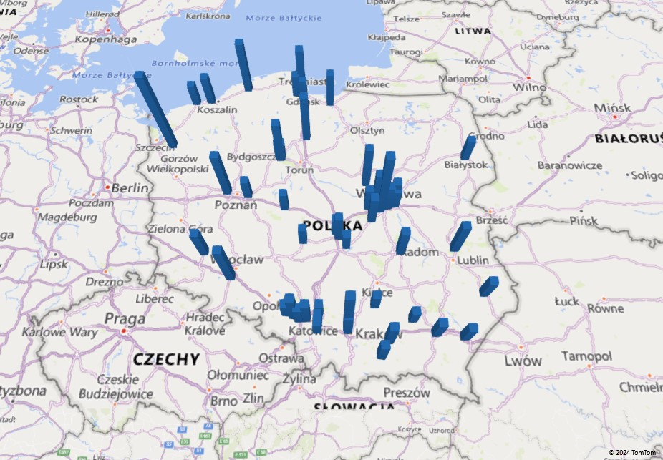
Figure 1.1. Map showing the customer volume served
Source: own elaboration

You have the opportunity to cooperate with 4 logistics operators who will guarantee the distribution of your products to your customers. You can choose only one logistics operator to handle your products. The start of cooperation with the new operator is scheduled for January 2025. You must sign the contract for one year.
Each operator proposed a different price list. Price lists differ in structure and value. However, each operator ensures the same quality of deliveries and customer service.
Below the structure of shipments that you delegate to a logistics operator for distribution is shown. The diagram shows the sum of pallet spaces and the number of shipments.

Figure 1.2. A chart showing the sum of pallet spaces and the number of shipments delegated to the logistics operator
Source: own elaboration

The next chart shows the number of pallet places versus time. There are noticeable increases in distributed shipments in Q2 and Q3 of each year.

Figure 1.3. A chart showing the number of pallet spaces versus time
Source: own elaboration

About 45% of deliveries are carried out to central warehouses and about 36% of deliveries are carried out on weekends.
In addition to the trend and seasonality resulting from the data, you know that the Sales Department will intensify its work on an additional increase in sales to new central warehouses (CW). In this case, shipments are expected to be consistent with the current average shipment volume to CW. It should be assumed that there will be 16 new recipients assigned to the central warehouse class. Recipients are located by the zip codes shown in the table below.
Table 1.1. New recipients located by zip codes
Zip code | Extra daily PS
1 | 10
5 | 15
12 | 9
14 | 14
21 | 5
27 | 12
30 | 15
41 | 8
44 | 13
51 | 15
62 | 5
64 | 6
71 | 5
80 | 12
90 | 10
95 | 7
Source: own elaboration

Additionally, the contract with recipients with numbers 31-39 ends soon, which should be taken into account when choosing the appropriate logistics operator.

DECISION PROBLEM
 | You have a history of the distributed volume and forecasts of changes in demand for the coming period. Based on the data, you must firstly forecast the distributed volume (sales) for the next 12 months. The most important thing is to choose appropriate forecasting models for all recipients (they may be different for each recipient). You should consider which logistics service provider to choose to distribute products to customers for the next 12 months. When choosing, you should only take into account the cost aspect, i.e. you should choose the cheapest operator. Please remember to take into account all the additional costs that are assigned to the price lists.  It should also be noted that when choosing, you should not be guided by the historically cheapest service offered by the logistics operator, but should select the operator that will distribute shipments at the cheapest rate in the next 12 months.  There are many additional costs in price lists that need to be taken into account. These are among others:  Table 2.1. Additional costs assigned to price lists  Source: own elaboration  The fuel correction has been forecast for the next 12 months, so it should be adopted in accordance with the data below.  Table 2.2. Fuel correction in individual price lists  Source: own elaboration  Price lists received from logistics operators are based on delivery kilometers, zip codes and a flat rate. For this reason, each price list will behave differently for each volume.  TASK
  Additional cost | Value
  E-toll | %
  Pallet replacement | PLN
  Weekend delivery | %
  Fuel correction | %
  Delivery from July to August | %
  Additional cost for daily uploads greater than 66 PS | %
  Additional cost for daily uploads smaller than 33 PS | %
  Fuel price
  Year | Month | Price list I | Price list II | Price list III | Price list IV
  2023 | May | 46,4% | 23,2% | 15,0% | 18,6%
  2023 | June | 56,8% | 28,4% | 15,0% | 22,7%
  2023 | July | 52,8% | 26,4% | 15,0% | 21,1%
  2023 | August | 47,6% | 23,8% | 15,0% | 19,0%
  2023 | September | 46,4% | 23,2% | 15,0% | 18,6%
  2023 | October | 59,4% | 29,7% | 15,0% | 23,8%
  2023 | November | 50,2% | 25,1% | 15,0% | 20,1%
  2023 | December | 47,6% | 23,8% | 15,0% | 19,0%
  2024 | January | 36,5% | 18,3% | 20,0% | 14,6%
  2024 | February | 31,8% | 15,9% | 20,0% | 12,7%
  2024 | March | 27,2% | 18,1% | 20,0% | 14,5%
  2024 | April | 22,8% | 15,2% | 20,0% | 12,2%
  2024 | May | 17,6% | 11,7% | 20,0% | 9,4%
  2024 | June | 3,0% | 2,0% | 20,0% | 3,4%
  2024 | July | 3,0% | 2,0% | 20,0% | 3,4%
  2024 | August | 3,0% | 2,0% | 20,0% | 3,4%
  2024 | September | 3,0% | 2,0% | 20,0% | 3,4%
  2024 | October | 3,0% | 2,0% | 20,0% | 3,4%
  2024 | November | 3,0% | 2,0% | 20,0% | 3,4%
  2024 | December | 5,0% | 3,3% | 20,0% | 5,6%
  2025 | January | 6,0% | 4,0% | 7,0% | 6,8%
  2025 | February | 7,0% | 4,7% | 7,0% | 7,9%
  2025 | March | 7,0% | 4,7% | 7,0% | 7,9%
  2025 | April | 7,0% | 4,7% | 7,0% | 7,9%
  2025 | May | 8,0% | 5,3% | 7,0% | 9,0%
   | Remember that the charge for replacing pallets applies only to EUR pallets.
  Complete the tasks below:
  - Choose the logistics operator that offered the best offer for the period June 2024-May 2025. You should choose the operator that offers the lowest distribution fee for the entire analysed period. Price lists and all additional costs should be included in the calculations.
  - Calculate which offer would be the most advantageous in the period June 2023 - May 2024. You should analyse data from the historical period and calculate whether another operator will offer a better price for a given volume.
  - Describe the risks associated with forecast inaccuracy. Can another operator be cheaper? What parameters does it depend on?
  - The forecast for the period June 2024 - May 2025 should be prepared per client, taking into account the information obtained from the Sales Department.

Business Analytics Skills for the Future-proof Supply Chains

